Bolly Movies, an Indian film production company, has a successful track record of producing numerous blockbuster films. While primarily catering to the Indian audience, they have decided to venture into the global market with their upcoming project scheduled for release in 2022.

I have analysed the IMDB movie database using SQL to gain valuable insights into the movie industry. By leveraging SQL queries, joins, subqueries, window functions and other SQL features, I have explored the database, performed various analyses, and drawn meaningful conclusions.

**Objective:**

The objective of this case study is to analyse the movie dataset using SQL queries and extract valuable insights to guide Bolly Movies in planning their new project. The analysis covers various aspects such as table exploration, movie release trends, production statistics, genre popularity, ratings analysis, crew members, and more.

**Key Learnings:**

This project was a hands-on learning experience that enhanced my SQL skills and analytical abilities. I gained proficiency in using SQL to explore and analyse large datasets, extract relevant information, and draw valuable insights. Through this project, I developed a deeper understanding of the movie industry, including trends, genre preferences, and factors influencing movie ratings.

**ER Diagram:**

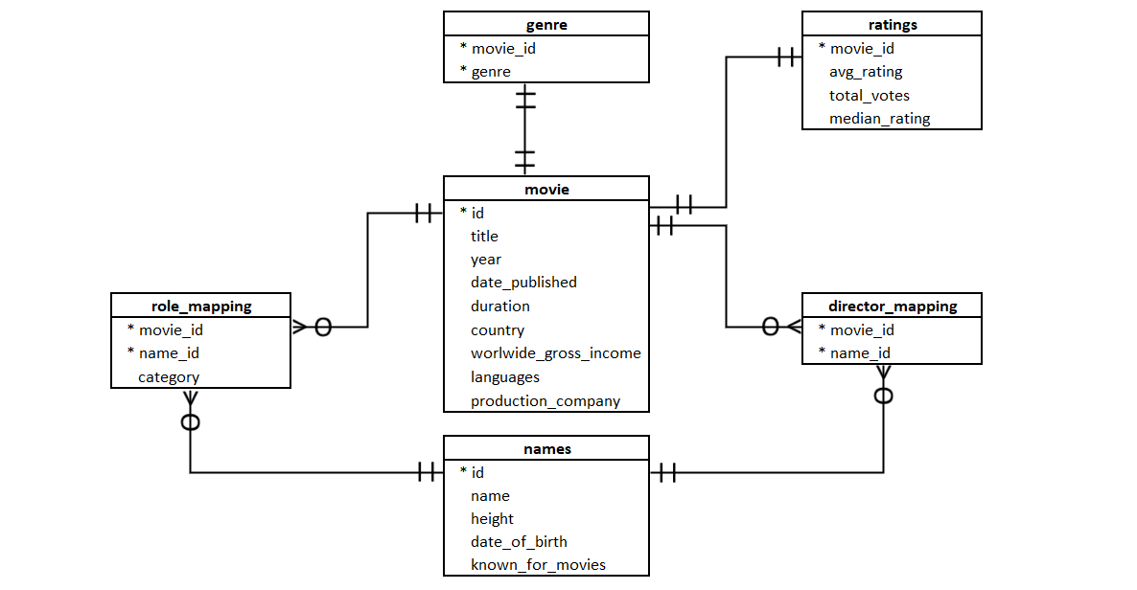

**Analysis:**

**Segment 1: Database - Tables, Columns, Relationships**

1. What are the different tables in the database and how are they connected to each other in the database?

There are total 6 tables in database namely Movies, Genre, Ratings, Role_mapping, Names, Director_Mapping.

Refer ER Diagram for relationships.

**Segment 2: Movie Release Trends**

1. Determine the total number of movies released each year and analyse the month-wise trend.

March is highlighted as a particularly suitable month for a movie release. Majority of the movies are released in the months of Sept, Oct, Nov in 2018 & 2017. In 2017, there were 3052 movies released which was highest in 3 years. While there was a big downfall in last 2 months of the year 2019. Only 113 movies were released during this period and that's the biggest concern. There might be several reasons like budget, quality, production reasons, subject matter.

1. Calculate the number of movies produced in the USA or India in the year 2019.

1059 movies were produced in USA or India in 2019.

**Segment 3: Production Statistics and Genre Analysis**

1. Identify the genre with the highest number of movies produced overall.

Drama genre has the highest no. of movies releases, indicating its popularity.

**Segment 4: Ratings Analysis and Crew Members**

1. Identify the top 10 movies based on average rating.
2. Determine the number of movies released in each genre during March 2017 in the USA with more than 1000 votes.

**Segment 5: Crew Analysis**

1. Determine the top three directors in the top three genres with movies having an average rating > 8.

|  |  |  |  |
| --- | --- | --- | --- |
| **Genre** | **Director_name** | **Num_movies** | **director_rk** |
| Action | Anthony Russo | 2 | 1 |
| Action | Joe Russo | 2 | 2 |
| Action | James Mangold | 2 | 3 |
| Comedy | Michael Powell | 1 | 1 |
| Comedy | Noah Baumbach | 1 | 2 |
| Comedy | Marc-André Lavoie | 1 | 3 |
| Drama | James Mangold | 2 | 1 |
| Drama | Marianne Elliott | 2 | 2 |
| Drama | M. Padmakumar | 1 | 3 |

Prominent Directors: James Mangold, Anthony Russo, and Joe Russo are noted as successful directors, and their work is suggested for review.

1. Find the top two actors whose movies have a median rating >= 8

|  |  |
| --- | --- |
| **Actor** | **Movie_count** |
| Mammootty | 8 |
| Mohanlal | 5 |

Highly Regarded Actors: Mammooty and Mohanlal are esteemed actors recommended for potential hiring by Bolly Movies. Vijay Sethupathi has the best average rating in Indian movies and is suggested for consideration.

1. Identify the top three production houses based on the number of votes received by their movies.

|  |  |
| --- | --- |
| **Production_company** | **Total_votes** |
| Marvel Studios | 2656967 |
| Twentieth Century Fox | 2411163 |
| Warner Bros. | 2396057 |

Successful Production Houses: Marvel Studios, Twentieth Century Fox, and Warner Bros are recognized as successful production companies, and their strategies are recommended for consideration.

1. Identify the top five actresses in Hindi movies released in India based on their average ratings.

Top Rated Hindi movies Actresses: Pranati Raj Prakash, Leera Kalijai, Puneet Sikka, Sanaya Irani, and Tabu are highly recommended for consideration.

**Segment 6: Broader Understanding of Data**

1. Identify the top three actresses based on the number of Super Hit movies (average rating > 8) in the drama genre.

|  |  |  |
| --- | --- | --- |
| **Actress_name** | **Movie_count** | **Avg_movie_rating** |
| Denise Gough | 2 | 8.95 |
| Amanda Lawrence | 2 | 8.95 |
| Susan Brown | 2 | 8.95 |

**Segment 7: Recommendations**

1. Based on the analysis, provide recommendations for the types of content Bolly movies should focus on producing.

From the analysis done, these are my recommendations for Bolly movies production house:

**1.Focus on Drama and comedy:**

According to the trend analysis, drama and comedy films are performing the best overall. Bolly Movies should keep emphasizing the creation of compelling, emotionally charged stories that connect with viewers.

**2. Explore Action and Comedy**:

The next best genres for bolly movies to study are action and comedy. Bolly movies can make pictures that appeal to a wider audience by branching out into action films with thrilling stunts and engaging storylines, as well as include comedy movies.

**3. International collaboration:**

Bolly movies can collaborate with international production companies as well as it is seen that countries like USA and UK have significantly high number of movies this will help to expand the global reach and appeal of Bolly Movies by catering to a broader audience.   
The top production houses based on the number of votes received by their movies like Marvel Studios, and Twentieth Century Fox can be collaborated with thus propelling their popularity and fanbase.

**4. Stay Innovative and Stay Informed:**Bolly movies can experiment with original concepts and unorthodox narrating techniques while keeping an eye on market trends, audience preferences, and industry advancements through ongoing market research. This helps them stay innovative and informed.

**5. Focus on Ratings and Reviews:**

Bolly Movies should focus on ratings and reviews to understand audience preferences and improve future projects. Collaborating with successful production houses like Marvel Studios, Twentieth Century Fox, and Warner Bros can ensure high-quality content. Prioritizing well-crafted films with positive reviews and high ratings will boost Bolly Movies' reputation and success in the industry.

**Conclusion:**

I thoroughly enjoyed working on this IMDB movie analysis project. It provided a valuable opportunity to apply SQL skills to real-world data and gain insights into the movie industry. I believe this project has not only improved my analytical abilities but also deepened my understanding of SQL as a powerful tool for data analysis.